# IT 315 Final Project Part I Solution Submission Template

This template is a guide for you to organize your information. To complete it, **replace the bracketed text with the relevant information.** Some areas may be too large or too small for the information you’re inserting. Adjust the size of the areas as necessary.

**Name:** [Joseph Silva Jr.]

**Date:** [01/30/21]

1. **Creation:** Generate your student information system (SIS) use case diagram. Refer to textbook pages 121–129.
2. [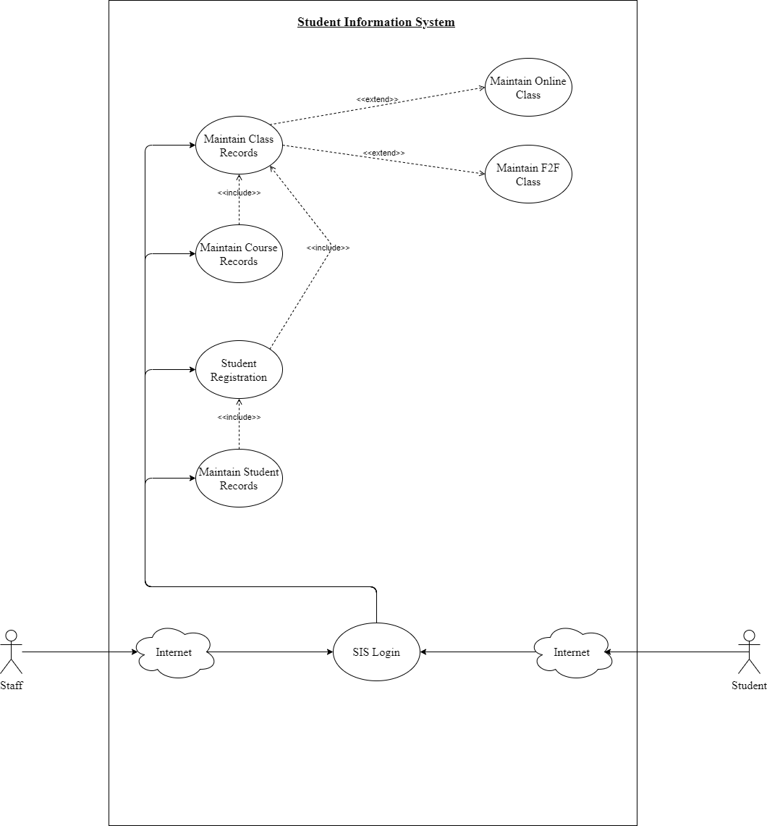]

Using the **use case description template** (refer to textbook pages 141–148), provide a description for **each** use case in your use case diagram:

**Use Case 1 description template:**

[

|  |  |  |
| --- | --- | --- |
| Use Case Name:  [Maintain Student Records] | ID:  [1] | Importance Level:  [3] |
| Primary Actor:  [Staff] | Use Case Type:  [Detail and Essential.] | |
| Stakeholders and Interests:  [Staff and Student.] | | |
| Brief Description:  [Area of the system that stores and displays records of each student’s general information] | | |
| Trigger:  [Staff and Student have access to student records. Staff only has ability to edit records.]  Type:  [External Trigger.] | | |
| Relationships   * Association:   [Staff and Student.]   * Include:   [Student’s General Information such as Student’s name, DOB, GPA, Student ID & Department.]   * Extend:   [Staff Ability to edit student records such as add, delete, and modify.]     * Generalization:   [Manage Student Records.] | | |
| Normal Flow of Events:   * Staff or Student triggers Student Records. * Staff or Student is able view general information of Students | | |
| SubFlows:   * Staff able to edit a student’s record by adding, deleting, or modifying information * After information changed, a confirmation requirement will be asked to staff. * After confirmation is completed, new information will be added to the records. | | |
| Alternate/Exceptional Flows:  [Insert information.] | | |

]

**Use Case 2 description template:**

[

|  |  |  |
| --- | --- | --- |
| Use Case Name:  [Maintain Course Records] | ID:  [2] | Importance Level:  [3] |
| Primary Actor:  [Staff] | Use Case Type:  [Detail and Essential.] | |
| Stakeholders and Interests:  [Staff and Student.] | | |
| Brief Description:  [Area of the system that stores and displays records of each course’s general information] | | |
| Trigger:  [Staff and Student have access to course records. Staff only has ability to edit records.]  Type:  [External Trigger.] | | |
| Relationships   * Association:   [Staff and Student.]   * Include:   [Courses’ General Information such as Course ID, name, credit hours, description & prerequisite courses.]   * Extend:   [Staff Ability to edit course records such as add, delete, and modify.]     * Generalization:   [Manage Course Records.] | | |
| Normal Flow of Events:   * Staff or Student triggers Course Records. * Staff or Student is able view general information of Courses. | | |
| SubFlows:   * Staff able to edit a course’s record by adding, deleting, or modifying information * After information changed, a confirmation requirement will be asked to staff. * After confirmation is completed, new information will be added to the records. | | |
| Alternate/Exceptional Flows:  [Insert information.] | | |

]

**Use Case 3 description template:**

[

|  |  |  |
| --- | --- | --- |
| Use Case Name:  [Maintain Class Records] | ID:  [3] | Importance Level:  [3] |
| Primary Actor:  [Staff] | Use Case Type:  [Detail and Essential.] | |
| Stakeholders and Interests:  [Staff and Student.] | | |
| Brief Description:  [Area of the system that stores and displays records of each class’ record’s general information] | | |
| Trigger:  [Staff and Student have access to course records. Staff only has ability to edit records.]  Type:  [External Trigger.] | | |
| Relationships   * Association:   [Staff and Student.]   * Include:   [Class General Information such as Course ID, begin date & end date.]   * Extend:   [Staff Ability to edit course records such as add, delete, and modify.]     * Generalization:   [Manage Class Records.] | | |
| Normal Flow of Events:   * Course needs to be created before class record can be created * Staff or Student triggers Class Records. * Staff or Student is able view general information of Classes. | | |
| SubFlows:   * Staff able to edit a class record by adding, deleting, or modifying information * After information changed, a confirmation requirement will be asked to staff. * After confirmation is completed, new information will be added to the records. | | |
| Alternate/Exceptional Flows:  [Insert information.] | | |

]

**Use Case 4 description template:**

[

|  |  |  |
| --- | --- | --- |
| Use Case Name:  [Maintain Student Registration Records] | ID:  [4] | Importance Level:  [3] |
| Primary Actor:  [Staff] | Use Case Type:  [Detail and Essential.] | |
| Stakeholders and Interests:  [Staff and Student.] | | |
| Brief Description:  [Area of the system that stores, displays and modify records of each student registration record.] | | |
| Trigger:  [Staff and Student have access to course records. Staff only has ability to edit records.]  Type:  [External Trigger.] | | |
| Relationships   * Association:   [Staff and Student.]   * Include:   [Registration processes log in for student ID]   * Extend:   [Ability to edit student registration records such as add, delete, and modify.]     * Generalization:   [Manage Student Registration Records.] | | |
| Normal Flow of Events:   * Staff or Student triggers Student Registration Records. * User adds a student ID information to gain access to registration records associated with that student ID. * Staff or Student is given the ability to add, delete, and modify registration records for the attached student ID. * New information stored after selection * Registration process restarts at Guideline (b) * Student can continue to add additional classes to registration query until query = 3. | | |
| SubFlows: | | |
| Alternate/Exceptional Flows:   * Any Online classes have a confirmation for student to stated they have the required software and hardware. * Student ID associated with a GPA of 3.5+ is given option for 4th class registration. * A prevention notification is displayed if a new registration = a prior registration in the student ID registration record query. After notification, registration process restarts at the rules and guidelines query. | | |

]

**Use Case 5 description template:**

[

|  |  |  |
| --- | --- | --- |
| Use Case Name:  [Online Classes] | ID:  [5] | Importance Level:  [4] |
| Primary Actor:  [Staff] | Use Case Type:  [Detail and Essential.] | |
| Stakeholders and Interests:  [Staff and Student.] | | |
| Brief Description:  [Area of the system that stores and displays information for the online classes] | | |
| Trigger:  [Staff and Student have access to course records. Staff only has ability to edit records.]  Type:  [External Trigger.] | | |
| Relationships   * Association:   [Staff and Student.]   * Include:   [Registration processes log in for student ID]   * Extend:   [Ability to edit student registration records such as add, delete, and modify.]     * Generalization:   [Manage Student Registration Records.] | | |
| Normal Flow of Events: | | |
| SubFlows: | | |
| Alternate/Exceptional Flows: | | |

**Use Case 6 description template:**

[

|  |  |  |
| --- | --- | --- |
| Use Case Name:  [F2F Classes] | ID:  [6] | Importance Level:  [4] |
| Primary Actor:  [Staff] | Use Case Type:  [Detail and Essential.] | |
| Stakeholders and Interests:  [Staff and Student.] | | |
| Brief Description:  [Area of the system that stores and displays information on F2F classes] | | |
| Trigger:  [Staff and Student have access to information.]  Type:  [External Trigger.] | | |
| Relationships   * Association:   [Staff and Student.]   * Include:   [Registration processes log in for student ID]   * Extend:   [Ability to edit student registration records such as add, delete, and modify.]     * Generalization:   [Manage Student Registration Records.] | | |
| Normal Flow of Events: | | |
| SubFlows: | | |
| Alternate/Exceptional Flows: | | |

1. **Testing:** Verify and validate your use case diagram and use case descriptions against the SIS requirements definition.

Check your diagram against the SIS requirements and write this review. In doing verification, the objective is to make sure that you are building software according to user specifications. Ask questions like these: Does each use case have the required functionality? Do all the use cases combined perform as a complete coherent system?

[Comparing the SIS guidelines and my diagram, we can see the nonfunctional requirements are taken care of at the beginning of the diagram. The diagram shows the two actors are the staff and the student, next it shows they can enter the system using internet with a mobile app and website access included. The last issue of security is handled with the system log in and it directs a user to certain gateways to the system. A staff member login will send them to the staff gateway, the student login will send them to the student gateway into the system, and unauthorized users will not gain access to the system.

Next, the system functional requirements are handled after log in. The records and registration system are open to the users, but only the staff has access to all areas of the system while the student has areas blocked from their access. Each use case has included attributes and extend options for authorized users to access. The registration area of the system also have the rules and exceptions during the registration process.]

1. **Approach Explanation:** Explain your approach to the problem, the decisions you made to arrive at your solution, and how you completed it.

Explain why you chose these particular use cases and why you chose the relationships between them. Explain your approach to creating your functional model and the design decisions you made to create it.

[I approached this assignment by following the Student Information System Guidelines and the created a workflow first in order to have a map for me to follow while writing my report. The reason I created my diagram model to show the route the users of the system can take and how the use cases were connected. I used color schemes to show the routes certain actors were allowed to go and to show general connection with the system. As I stated below, I had to keep expanding the system in order to make sure all use cases and their requirements would fit inside of the system.]

1. **Self-Reflection:** Reflect on this experience and the lessons you learned from it.

These are your reflections on what you learned. Address what you found challenging and what you found easy. Discuss your experience creating your functional model and the lessons you learned from it. Specifically, draw connections between your experience and the object-oriented techniques and methods discussed in this course.

[One of the challenges I had was the relationships between use cases because of the two actors having different access levels. I used colored lines in order to make sure the diagram did not get confusing on which actor was allowed access to certain areas of the system. The blue lines give the staff actor access to all of the areas of the system, while the red lines give the student actor limited access to areas of the system. I used black lines in order to show general relationships to areas within the system. Overall, I had a great experience creating the diagram, but I did have to revise my diagram multiple time in order to make sure I had all use cases, attributes, and rules inside of the system. I had to expand my system square box multiple times to make room for the use cases. Once I color schemed the relationships, I was able to understand the system better and I was able to map through the rules and guidelines for each use case.]